K6 Tetra-Ubiquitin (Ub4) S20C Mutant
Cat. # SI0624

Background: | Mitophagy (the autophagic processing of damaged mitochondria) via Parkin activation is mainly promoted by K6 and K63 linked chains. K6-linked ubiquitination is also a main contributor to the DNA damage response and acts as a DNA-binding enhancer during the innate immune system response. These chain types are also involved in protein stabilization and other non-degradative processes. The serine in position 20 has been changed to a cysteine.  These tetra-ubiquitin chains are generated from the enzymatic linkage of wild-type ubiquitin through lysine 6.
Application: | - To investigate enzymes that cleave this specific peptide linkage between two ubiquitin molecules.  - To better understand the mechanisms of ubiquitin-activating (E1) or ubiquitin-conjugating (E2) enzymes, ubiquitin-associated domains (UBA), or ubiquitin-interacting motifs (UIMs) among others.  - To use as a label through biotinylation or fluorescence.

Product Information
Purity: | > 70% by SDS-PAGE and Mass Spectrometry
Molecular Weight: | 34267 Da
Physical State: | liquid
Quantity: | 25, 50 µg
Solubility: | >30 mg/mL
Storage: | -80º C. Avoid repeated freeze/thaw cycles

References

- Michel, M. A., Swatek, K. N., Hospenthal, M. K., & Komander, D. (2017). Ubiquitin linkage-specific affimers reveal insights into K6-linked ubiquitin signaling. Molecular cell, 68(1), 233-246.
- Tai, H. C., & Schuman, E. M. (2008). Ubiquitin, the proteasome and protein degradation in neuronal function and dysfunction. Nature Reviews Neuroscience, 9(11), 826-838.
- Van Huizen, M., & Kikkert, M. (2020). The role of atypical ubiquitin chains in the regulation of the antiviral innate immune response. Frontiers in cell and developmental biology, 7, 392.

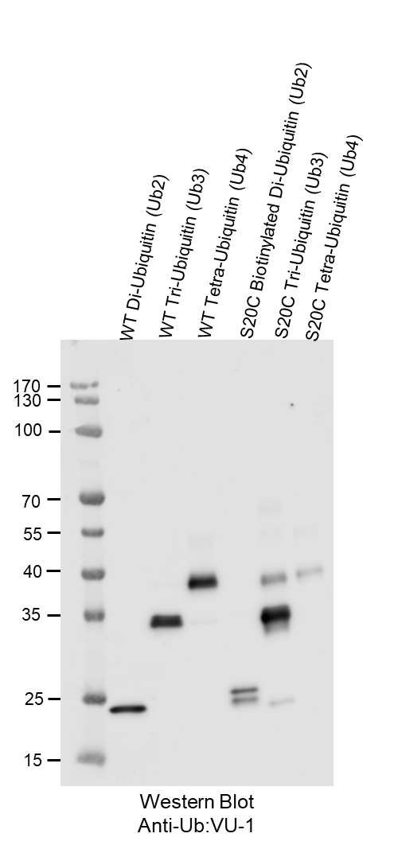
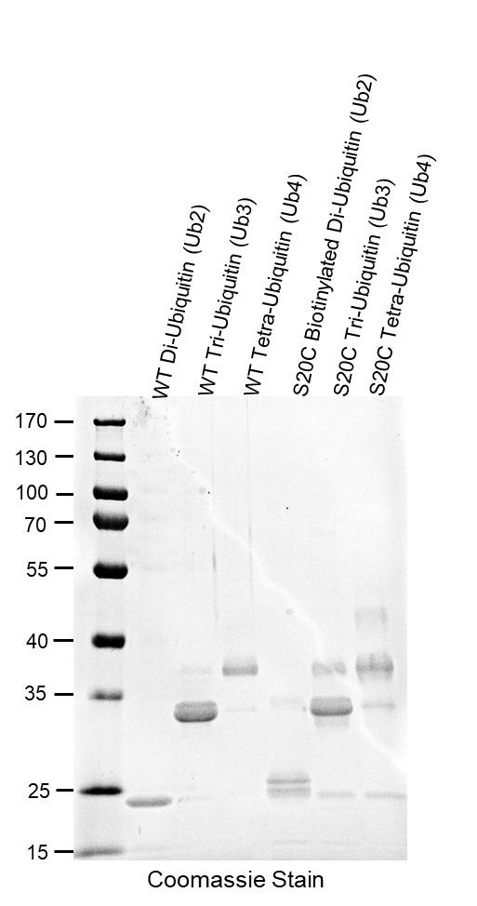
Figure 2. Image shows the mass spectrometry readout, showing a mass of 34267 Da.
Figure 1. Image on the left shows 1 µg of each sample (labeled on top) run through SDS-PAGE and with a Coomassie Stain. Image on the right shows 100 ng of each sample (with the exception of S20C tetra-ubiquitin) run through SDS-PAGE and then transferred to a nitrocellulose membrane for a Western Blot with an anti-ubiquitin VU-1 antibody.

