Cereblon/DDB1/Cul4A/Rbx1 Complex
Cat. # UB330

Background: | Cereblon/DDB1/Cul4A/Rbx1 complex of human Cereblon (GenBank Accession No. NM_016302) a.a. 2-442(end) with N-terminal FLAG-tag and MW= 51 kDa, human DDB1 (GenBank Accession No. NM_001923), a.a. 1-1140(end) with N-terminal FLAG-tag and MW= 128 kDa, human Cul4A (GenBank Accession No. NM_003589), a.a. 2-759(end) with N-terminal Histag and MW= 88 kDa, human Rbx1 (GenBank Accession No. NM_014248), a.a. 2-108(end) with N-terminal His-tag and MW= 13 kDa, co-expressed in a HEK293 expression system
Application: | • Protein degradation  • PROTAC design  • Selectivity Profiling

Product Information
Purity: | ≥ 90% by SDS-PAGE
Molecular Weight: | Cereblon: 51 kDa, DDB1: 128 kDa, Cul4A: 88 kDa, Rbx1: 13 kDa
Physical State: | Liquid
Quantity: | 10µg, 50µg
Buffer: | 40mM Tris-HCl, pH 8.0, 110nM NaCl, 2.2 mM KCl, 0.04% Tween-20, 20% glycerol
Storage: | -80º C. Avoid repeated freeze/thaw cycles

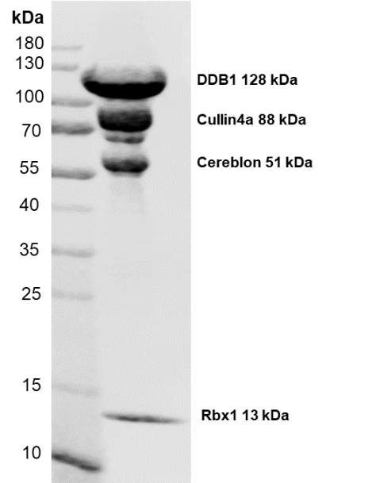
Product QC

Figure 1. Coomassie stain, 10-20% SDS-PAGE loading 10µg CRBN complex ≥90% purity.

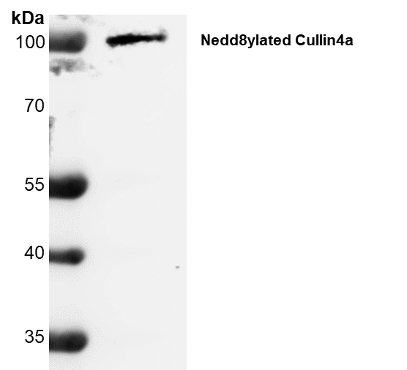
Figure 2. Anti-NEDD8 western blot using Cell Signaling Technology NEDD8 Antibody #2745 at 1:1000 dilution. 1µg of CRBN complex loaded on 10-20% SDS-PAGE.
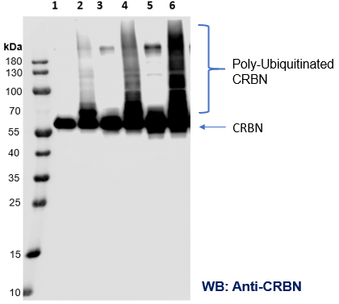
Figure 3. CRBN Activity Assay – auto-ubiquitination of CRBN Complex in the presence of UbE1, E2, Ubiquitin, and ATP. Reactions were performed on 20µL scale with 1 hour incubation at 37°C. Total reaction volume was loaded on 10-20% SDS-PAGE gel to be transferred to nitrocellulose membrane for detection of CRBN auto-ubiquitination. From left to right, Lane 1: 6.25nM CRBN minus Ube1, Lane 2: 6.25nM CRBN plus UbE1, Lane 3: 12.5nM CRBN minus UbE1, Lane 4: 12.5nM CRBN plus UbE1, Lane 5: 25nM CRBN minus UbE1, Lane 6: 25nM CRBN plus UbE1. Cell Signaling Technology Anti-CRBN (D8H3S) Rabbit mAb #71810, 1:1000 dilution.

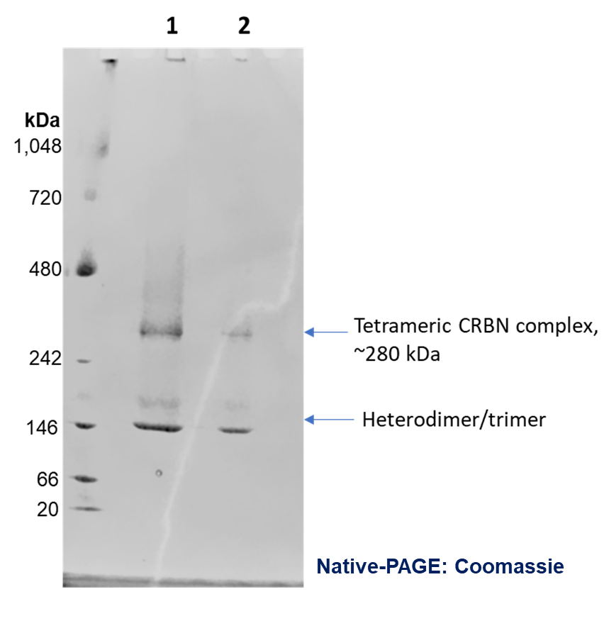

Figure 4. CRBN Complex Formation – Coomassie stain of 3µg (lane 1) and 1µg (lane 2) CRBN complex loaded on 4-16% bis-tris native-page gel.

References
- Gang, Lu., et al., Science. 2014; 343(6168): 305-309.
- Zhu, Y.X., et al., Blood. 2011; 118: 4771-4779.

